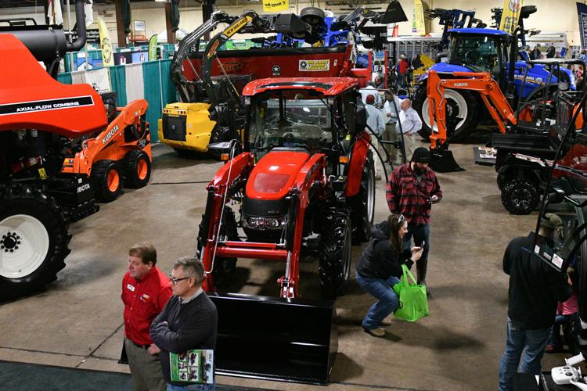

EXHIBITOR

MANUAL

JANUARY 14-16, 2024

QUAD CITIES FARM EQUIPMENT SHOW
QCCA EXPO CENTER
2621 FOURTH AVENUE
ROCK ISLAND, IL 61201

IMPORTANT – PLEASE READ CAREFULLY
Failure to act promptly could mean overtime charges, lack of immediate service at the show, or other unnecessary inconveniences.
This exhibitor’s manual has been compiled to furnish exhibitors and their personnel with more complete details affecting all phases for the successful operation of your exhibit in the show. Questions on any points will be answered promptly by an inquiry to Show Management, Rob Junker. The order form is on the last page of this manual. It details rental equipment/utilities/services, floral decoration, shipping, labor, and forklift rental. Also enclosed are 2 maps directing you to the facility. Please note that it is best to drive down 5th Avenue and then turn left on 26th Street to 4th Avenue at which point you can turn right on 4th and enter the QCCA Expo Center parking lot.

All rates and data were verified as of printing time. Should any changes occur, supplementary bulletins will be issued promptly. The services listed are for your convenience only. YOU ARE NOT OBLIGATED TO USE THEM. The only exception would be that if wiring, additional lighting, power, or plumbing is required for your exhibit, it must be handled by the official contractors of the QCCA Expo Center.

Management suggests that you employ the services of the Expo Center for the greatest efficiency and ease during the move-in and move-out periods. However, you are certainly welcome to bring your own booth furnishings and you are permitted to have your own company employees unload and service your exhibit. If you need to hire help for unloading and labor or require fork- lift services, please contact the QCCA one month in advance to arrange. Building carts are available at no charge but you should make sure that you bring whatever other tools are needed with you. Also, if you intend to spray paint, please do it either outside of the facility or bring adequate material to cover and protect the exhibit floor.

The enclosed order forms, which must be accompanied by a check, where applicable, should be completed and returned to the QCCA at your earliest convenience but no later than 2 weeks prior to opening to guarantee the rates and services requested. In the case of the FREE Program listing, management cannot guarantee accuracy if the form is not returned to us within 30 days of opening. We urge you to give this manual to those having responsibility for your display.

Thank you for being a part of the 2024 Quad Cities Farm Show! I look forward to seeing you.

Sincerely,

Robert Junker
Show Director
QCCA Expo Center

QCCA EXPO CENTER 2621 4TH AVENUE, ROCK ISLAND, IL 61201
DIRECTIONS TO THE SHOW
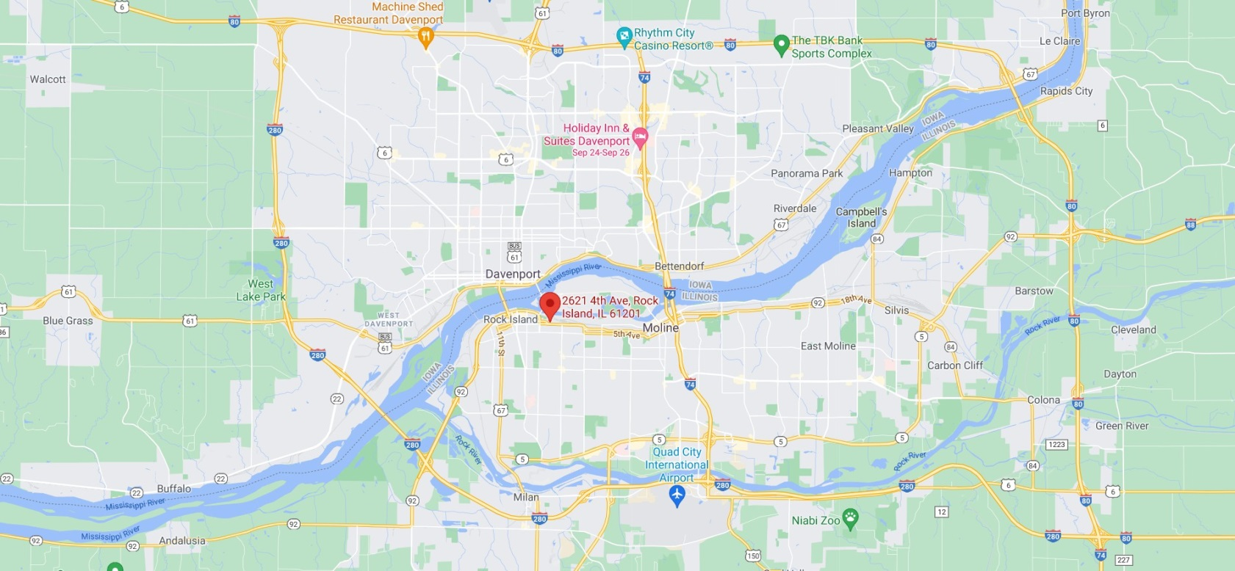

FROM THE WEST
Take I-280 into Illinois
Take IL92 exit into downtown along riverfront and then as it bends away from the river till you reach 5th Ave.
Turn left on 5th Ave,staying in left lane.
Go 2 blocks to 26th Street.
Turn left and pull up to stop sign.
Expo Center is just across the street.
FROM THE SOUTH
Take I-74 or US67 to I-280
Take IL92 exit into downtown along riverfront and then as it bends away from the river till you reach 5th Ave.
Turn left on 5th Ave., staying in left lane.
Go 2 blocks to 26th Street.
Turn left and pull up to stop sign.
Expo Center is just across the street.
FROM EAST OR NW ILLINOIS
Take I-88 to I-80 East
Take I-80 East to I-280 West
Take IL92 exit into downtown along riverfront and then as it bends away from the river till you reach 5th Ave.
Turn left on 5th Ave, staying in left lane.
Go 2 blocks to 26th Street.
Turn left and pull up to stop sign.
Expo Center is just across the street.
FROM THE NORTH
Take US61 through Davenport to US67
Take US67 across Centennial Bridge into Rock Island
Turn left on 5th Ave, staying in left lane.
Go 2 blocks to 26th Street.
Turn left and pull up to stop sign.
Expo Center is just across the street.

DATES & HOURS

Move In Thursday, January 11 9 am – 5 pm

Friday, January 12 8 am – 5 pm

Saturday, January 13 8 am – 7 pm

Show Hours Sunday, January 14 10 am – 5 pm

Monday, January 15 9 am – 5 pm

Tuesday, January 16 9 am – 3 pm

Move Out Tuesday, January 16 3 pm – 9 pm

Wednesday, January 17 8 am – 2 pm

PLEASE NOTE THAT THIS IS AN EXTENDED MOVE IN PERIOD AND WE WOULD LIKE TO RESERVE THURSDAY FOR ONLY THE BIG EQUIPMENT DISPLAYS. ALL OTHERS MAY COME ON FRIDAY OR SATURDAY, AT ANY TIME OF THE DAY THAT IS CONVENIENT FOR YOU. AS WE HAVE 3 MOVE IN DOORS, THERE IS NO NEED FOR A MOVE IN SCHEDULE. WE ASK THAT YOU DO NOT ATTEMPT TO MOVE EQUIPMENT IN ON OPENING MORNING AS WE PREFER TO KEEP THE MOVE IN DOORS CLOSED FOR WARMTH.

GENERAL INFORMATION
SHOW OFFICE: WILL OPEN AT 8 AM ON THURSDAY, JANUARY 11. THE OFFICE TELEPHONE NUMBER IS 309-788-5912. WE REQUEST THAT EXHIBITORS DELEGATE ONE AUTHORIZED PERSON TO DEAL WITH MANAGEMENT IN ALL MATTERS RELATING TO YOUR SHOW PARTICIPATION. REMEMBER, THE SHOW OFFICE IS ALWAYS OPEN AND IT IS THERE TO SERVE YOU.
MOVE IN: MOVE IN WILL BEGIN AT 9 AM ON THURSDAY, JANUARY 11 WHICH WILL BE RESERVED FOR THE VERY LARGE DISPLAYS THAT REQUIRE A NEARLY EMPTY HALL FOR ROOM TO MANEUVER. FRIDAY AND SATURDAY WILL BE FOR GENERAL MOVE IN OF ALL DISPLAYS BEGINNING AT 8 AM EACH DAY. WE WILL UTILIZE 3 MOVE IN DOORS; ONE ADJACENT TO THE FRONT ENTRANCE, ONE ADJACENT TO THE CONCESSION AREA, AND ONE BEHIND BOOTH 937A AS MARKED ON THE SHOW FLOOR PLAN. ALL EXHIBITORS ARE WELCOME AT 8 AM ON OPENING DAY, SUNDAY, JANUARY 14 FOR LAST MINUTE CLEANING AND POLISHING OF THEIR DISPLAYS, BUT WE ASK THAT YOU DO NOT ATTEMPT TO MOVE IN EQUIPMENT THAT MORNING.
EXHIBITOR BADGES: PLEASE FILL OUT AND RETURN THE FORM ENCLOSED SO THAT YOUR BADGES CAN BE PREPARED IN ADVANCE SO THEY WILL BE READY FOR YOU TO PICK UP AT THE SHOW OFFICE DURING MOVE IN. IF ADDITIONAL BADGES ARE NEEDED, THEY WILL BE READILY AVAILABLE DURING SHOW HOURS. ORDER ONLY IF YOU WANT THEM. THEY ARE FOR YOUR CONVENIENCE ONLY.
COMMISSARY AND EXHIBITOR DINING: THERE IS A SIT-DOWN CONCESSION AREA WITHIN THE COMPLES TO SERVE LIGHT SNACKS, SANDWICHES AND HOT AND COLD DRINKS. IT IS AN IDEAL ARA FOR EXHIBITORS AND THEIR GUESTS OR CUSTOMERS TO GET AWAY FROM THE EXHIBIT FLOOR AND RELAX.
SHOW LABOR AND DÉCOR: THE EXPO CENTER WILL FUNCTION AS BOTH. ENCLOSED WITH THIS MANUAL IS THE ORDER FORM FOR ALL OF THE SERVICES WE PROVIDE. SHOULD YOU ELECT TO USE ANY OF THESE SERVICES, PLEASE MAIL/EMAIL THE APPROPRIATE FORM TO US. ALL 10- FOOT BOOTH EXHIBITORS WILL AUTOMATICALLY RECEIVE THE STANDARD BOOTH BACKGROUND AND THE 2 LINE COMPANY ID SIGN SO YOU DON’T HAVE TO ORDER THOSE.
ELECTRIC WIRING: ALL ELECTRIC WIRING MUST BE MADE BY THE EXPO CENTER ELECTRICIAN ONLY! IF YOU REQUIRE ELECTRICITY FOR YOUR EXHIBIT, PLEASE FILL OUT THE UTILITY/SERVICES FORM AND RETURN WITH PAYMENT.
CLOSING, BREAKDOWN/MOVE OUT: BREAKDOWN WILL BEGIN IMMEDIATELY AFTER THE SHOW CLOSES AT 3 PM ON TUESDAY, JANUARY 16. NO EARLY MOVE OUT WILL BE ALLOWED. MOVE OUT WILL CONTINUE WEDNESDAY JANUARY 17 AT 8 AM AND ALL EXHIBITS MUST BE REMOVED BY 2 PM.
SECURITY: 24 HOUR SECURITY WILL BE PROVIDED FROM MOVE IN THROUGH MOVE OUT
SHIPPING: THE EXPO CENTER IS AVAILABLE TO ASSIST WITH ANY SHIPPING ARRANGEMENTS EITHER TO OR FROM THE CENTER. A FULL EXPLANATION OF SHIPPING SERVICES AND A SERVICE ORDER FORM IS ENCLOSED.
INSURANCE LIABILITY: THE EXHIBITOR IS ENTIRELY RESPONSIBLE FOR THE SPACE THAT IS ALLOTTED TO YOU AND AGREES TO REIMBURSE THE CENTER FOR ANY DAMAGE TO FLOORS AND WALLS IN THAT SPACE. THEREFORE, IT IS REQUIRED THAT YOU CONTACT YOUR OWN INSURANCE COMPANY TO PURCHASE AN INEXPENSIVE FLOATER WHICH WILL ALSO COVER YOU FOR THEFT.
PRESS AND PUBLIC RELATIONS: A SERIES OF PRESS RELEASES WILL BE ISSUED BY MANAGEMENT TO OVER 300 PUBLICATIONS. PLEASE SEND PRESS MATERIAL TO US IF YOU WISH TO BE INCLUDED IN THIS PROGRAM.

ADVERTISING: IT WOULD BE EXTREMELY BENEFICIAL IF YOU WOULD INCLUDE MENTION OF YOUR PARTICIPATION IN YOUR NORMAL ADVERTISING. JUST A SIMPLE “SEE US AT THE QUAD CITIES EXPOFARM EQUIPMENT SHOW” WOULD BE FINE.
PROGRAM BOOK: A FREE EXHIBITOR LISTING WILL BE GIVEN TO EVERY SHOW ATTENDEE AND EVERY EXHIBITOR IS ENTITLED TO A LISTING WHICH WILL ASLO INCLUDE A SEPARATE HEADING FOR ALL THE BRAND NAMES THAT YOU EXHIBIT. PLEASE RETURN THE PROGRAM FORM TO MANAGEMENT BY DECEMBER 10 SO THAT WE CAN LIST YOU ACCURATELY. THIS LISTING WILL BE A PART OF ILLINOIS AGRI NEWS AND A PART OF THEIR SPECIAL SHOW ISSUE. IT WILL BE DISTRIBUTED BY THEM AT THE SHOW. PLEASE CONSIDER ADVERTISING YOUR PRODUCT OR SERVICE IN THIS SECTION.

HOTELS:
WE HAVE SECURED A DISCOUNT RATE OF $72 + TAX AT THE HOLIDAY INN, ROCK ISLAND. IT IS A VERY QUICK DRIVE FROM THE EXPO CENTER. THIS IS A DISCOUNTED RATE FOR ALL VENDORS. THE RATE IS FOR ONE ROOM WITH A KING OR 2 QUEEN BEDS. OFFER IS BASED ON AVAILABILITY AND CANNOT BE USED WITH OTHER DISCOUNTED OR NEGOTIATED RATES. CALL THE HOLIDAY INN AT 309-794-1212 AND ASK FOR THE QUAD CITIES FARM SHOW RATE.
THERE ARE MANY OTHER HOTELS IN THE AREA THAT DO NOT OFFER SHOW RATES BUT ARE CONVENIENT AND FAIRLY PRICED INCLUDING THE RADISSON IN MOLINE, IL; THE HAMPTON INN AND THE HOLIDAY INN EXPRESS IN MOLINE, IL AND JUMER’S CASINO HOTEL IN ROCK ISLAND.

QUAD CITIES FARM EQUIPMENT SHOW ORDER FORM FOR EXHIBITOR BADGES

SEND TO: ROB JUNKER
QCCA EXPO CENTER
2621 4TH AVENUE
ROCK ISLAND, IL 61201
EMAIL: rjunker@qccaexpocenter.com

Exhibitor badges will be furnished to you for the representatives of your company that will be manning your exhibit at the show. Credentials will not be mailed but may be picked up during move in at the show office. If additional credentials are needed, they will be readily available at the show office during show hours.

PLEASE RETURN BY DECEMBER 13, 2023!

COMPANY: _________________________________________________________ BOOTH #:_________

LIST WORKING PERSONNEL ( PLEASE PRINT)
1)
2)
3)
4)
5)
6)
7)
8)
9)
10)
11)
12)
13)
14)
15)

QUAD CITIES FARM EQUIPMENT SHOW FORKLIFT ARRANGEMENT

SEND TO: ROB JUNKER
QCCA EXPO CENTER
2621 4TH AVENUE
ROCK ISLAND, IL 61201
EMAIL: rjunker@qccaexpocenter.com

AS IN PAST YEARS, THE QC FARM EQUIPMMENT SHOW WILL CONTINUE THE ARRANGEMENT FOR RENTING FORKLIFT SERVICE. THE FORKLIFTS WILL BE OPERATED BY QCCA EXPO VOLUNTEERS. THE FEE STRUCTURE WILL REMAIN THE SAME AT $40.00 ONE TIME FEE FOR FORK LIFT USE. THIS WILL COVER MOVE IN AND MOVE OUT. IF YOU REQUIRE THIS SERVICE, PLEASE FILL OUT THE FORM AND SEND TO THE ABOVE WITH A CHECK FOR $40 FOR THE QCCA EXPO FARM SHOW

PLEASE RETURN BY DECEMBER 13, 2023!

COMPANY: _________________________________________________________ BOOTH #:_________

DAY FORKLIFT NEEDED FOR MOVE IN_____________________

COMPANY REP NAME__________________________________

QUAD CITIES FARM EQUIPMENT SHOW ORDER FORM FOR FREE SHOW LISTING

SEND TO: ROB JUNKER
QCCA EXPO CENTER
2621 4TH AVENUE
ROCK ISLAND, IL 61201
EMAIL: rjunker@qccaexpocenter.com

A free exhibitor listing will be given out to every attendee. Each exhibitor is entitled to a listing but we need your help to ensure that you are listed accurately and that all of your brand names are included. IF YOU ARE A DISTRIBUTOR OR A MANUFACTURER REP AND HAVE MORE THAN ONE MANUFACTURER LISTED IN YOUR BOOTH, WE WOULD LIKE TO LIST EACH ONE OF YOUR PARTICIPATING COMPANIES UNDER BOTH YOUR HEADING AND THEIR OWN, IN CARE OF YOU.

This information will be given to Illinois Agri News for their special show issue which will be handed out from their booth and the front entrance to show visitors and will serve as the Official Show Program. Other publications may also do show issues but the official program will be by Agri News, and we encourage you to consider advertising in the special show section. Illinois Agri News can be reached at 815-223-2558.

MANAGEMENT CANNOT GUARANTEE ACCURACY OF YOUR LISTING IF THIS FORM IS NOT RECEIVED BY DECEMBER 13, 2023!

COMPANY: _________________________________________________________ BOOTH #:_________
STREET ADDRESS:______________________________________________________________________
CITY:__________________________________________________________STATE:_____ZIP:________
PHONE:_________________
PRODUCTS OR BRAND NAMES TO BE DISPLAYED (PLEASE PRINT):
______________________________________________________________________________________________________________________________________________________________________________________________________________________________________________________________________________________________________________________________________________________________________________________________________________________________________________________________________________________________________________________________________________________________________________________________________________________________________________________________________________________________________________________________________________________________________________________________________________________________________________________________________________________________________________________________________________________________________________________________________________________________

Farm Show 2024 ***RETURN THIS FORM TO:

QUAD CITY CONSERVATION ALLIANCE
2621 4TH Avenue
EXHIBITOR _______________________________________ Rock Island, IL 61201
Phone: 309-788-5912
Booth# __________________________________ Fax: 309-788-9619
Website: www.qccaexpocenter.com
CONTACT ____________________________________ E-Mail: info@qccaexpocenter.com

EQUIPMENT/ELECTRICAL ADVANCE LOAD IN SHOW DAY QUANTITY TOTAL

DRESSED TABLE 6’ L X 30” H (INCL. SKIRT & COVER) . . . . $35.00 $45.00 $70.00 __________ $ _________________

DRESSED TABLE 8’ L X 30” H (INCL. SKIRT & COVER). . . . . $42.00 $50.00 $84.00 __________ $ _________________

DRESSED TABLE 6’ L X 40” H (INCL. SKIRT & COVER) . . . . $42.00 $50.00 $84.00 __________ $ _________________

DRESSED TABLE 8' L X 40" H (INCL. SKIRT & COVER) . . . . . $42.00 $50.00 $84.00 __________ $ _________________

TABLE 6’ L X 30” H . . . . . . . . . . . . . . . . . . . . . . . . . . . . . . . . . . . $25.00 $27.00 $44.00 __________ $ _________________

TABLE 8’ L X 30” H . . . . . . . . . . . . . . . . . . . . . . . . . . . . . . . . . . . $25.00 $27.00 $44.00 __________ $ _________________

TABLE 6’ L X 40” H . . . . . . . . . . . . . . . . . . . . . . . . . . . . . . . . . . . $25.00 $27.00 $44.00 __________ $ _________________

TABLE 8’ L X 40” H . . . . . . . . . . . . . . . . . . . . . . . . . . . . . . . . . . . $25.00 $27.00 $44.00 __________ $ _________________

PADDED STOOL . . . . . . . . . . . . . . . . . . . . . . . . . . . . . . . . . . . . . $ 12.00 $15.00 $20.00 __________ $ _________________

CHAIR . . . . . . . . . . . . . . . . . . . . . . . . . . . . . . . . . . . . . . . . . . . . . . $ 6.00 $ 8.00 $12.00 __________ $ _________________

EASEL (WOOD TRIPOD) . . . . . . . . . . . . . . . . . . . . . . . . . . . . . . . $ 7.00 $ 8.00 $14.00 __________ $ _________________

WASTEBASKET . . . . . . . . . . . . . . . . . . . . . . . . . . . . . . . . . . . . . . $ 4.00 $ 5.00 $ 8.00 __________ $ _________________

32” COLOR TV/W/Stand . . . . . . . . . . . . . . . . . . . . . . . . . . . . . . . $100.00 $125.00 $200.00 ___________ $ _________________

DVD/VCR . . . . . . . . . . . . . . . . . . . . . . . . . . . . . . . . . . . . . . . . . . . $100.00 $125.00 $200.00 ___________ $ _________________

110 ELECTRIC/DOUBLE OUTLET . . . . . . . . . . . . . . . . . . . . . . . . $65.00 $90.00 $130.00 ___________ $ _________________

220 VOLT (AVAILABLE UPON REQUEST) . . . . . . . . . . . . . . . . . $110.00 $165.00 $220.00 ___________ $ _________________

CARPET PIECE (10 X 10) . . . . . . .. . . . . . . . . . . . . . . . . . . . . . . $25.00 $35.00 $45.00 __________ $ _________________

CARPET PIECE (10 X 20) . . . . . . . . . . . . . . . . . . . . . . . . . . . . . $35.00 $45.00 $65.00 ___________ $ _________________

TOTAL OF ALL EQUIPMENT/ELECTRIC CHARGES $ _________________
PAID BY:
CHECK# ___________VISA OR M/C# _______________________________EXP. ____________ZIP Code ______________ CASH _________

_________________________________________________________ _______________________________ ________________________________
SIGNATURE OF REPRESENTATIVE PHONE NUMBER DATE

---------------------------------------------------------------------------------
EMAIL ADDRESS

